Experiment 3
Description: Create a simple cloud software application for Property Buying & Rental process (In Chennai city) using any Cloud Service Provider to demonstrate SaaS.
Aim
To build a cloud-enabled property buying and rental portal and publish it as SaaS.
Procedure
- Create modules: Property Listings, Filters, Contact Owner.
- Use cloud database for storing listings.
- Deploy application on cloud platform.
- Test property search and inquiry features.
Output:
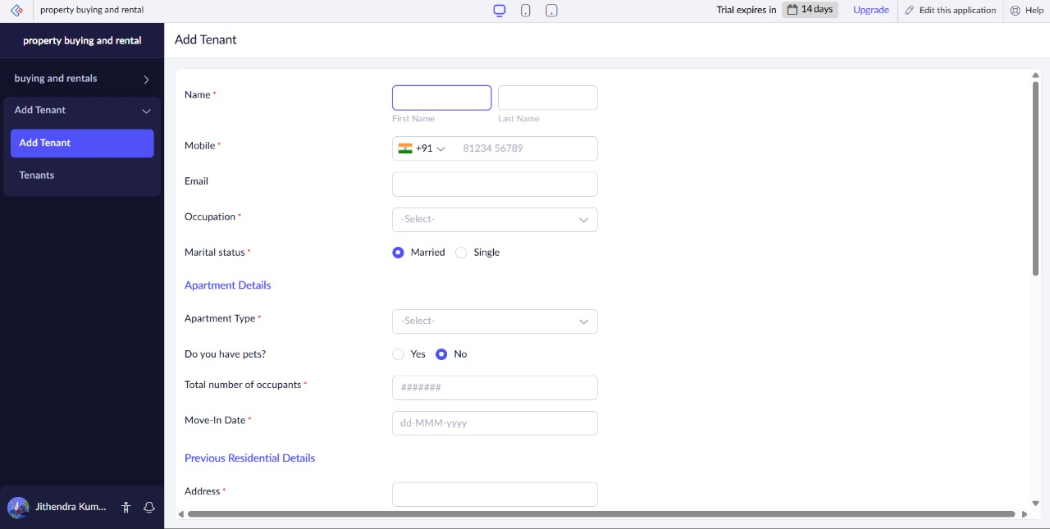
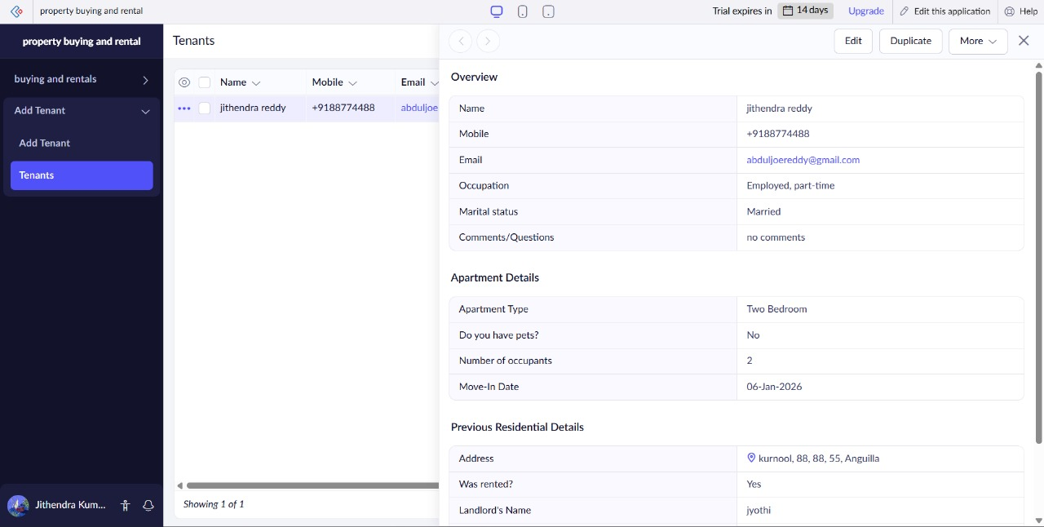
Result
A cloud-hosted property management system was created and deployed successfully.

